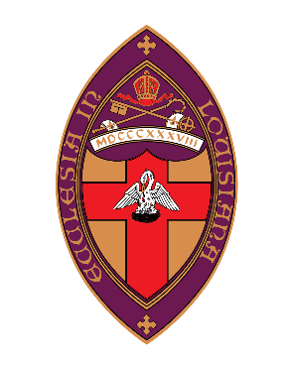

Episcopal Diocese of Louisiana
Community Mission Appeal
Call for Proposals
Application Deadline: October 1, 2021

… Come, you that are blessed of my Father, inherit the kingdom prepared for you from the foundation of the world; for I was hungry and you gave me food, I was thirsty and you gave me something to drink, I was a stranger and you welcomed me, I was naked and you gave me clothing, I was sick and you took care of me, I was in prison and you visited me… Truly I tell you, just as you did it to one of the least of these who are members of my family, you did it to me. (Matthew 25:34-36, 40)

Background: The Community Mission Appeal has been established in order to help parishes in the Episcopal Diocese of Louisiana to serve God through reaching out to their neighbors who are most in need. Projects awarded funding will support the work of Episcopal congregations to serve those who live nearby and are in need, but who are not necessary members of the parish. Mission outreach to the wider community should be a feature of these projects.

Examples of Eligible Projects: Examples might include the following, and other ideas are also encouraged:
- Feeding ministries for the destitute
- Prison ministries
- Afterschool or tutoring programs that serve low-income children
- Medical missions that provide health care to the indigent
- Teaching English as a Second language to immigrants

Applications are not encouraged under this announcement to support school scholarships, construction, projects that serve people outside of the Diocese of Louisiana, and initiatives that focus mainly on advocacy.

Donations: Funds for the Community Mission Appeal are being raised through parish appeals throughout the Diocese, as well as individual contributions. The amount to be distributed will depend on the success of those efforts.

To make a tax-deductible donation, please visit http://www.edola.org/cma, or mail your check (with “Community Mission Appeal Donation” written in the memo line) to the following address:
Community Mission Appeal
Episcopal Diocese of Louisiana
1623 Seventh Street
New Orleans, LA 70115

Eligible Applicants: Episcopal congregations within the Diocese of Louisiana

Award Date and Grant Period: Decisions will be announced at the Diocesan Convention on November 5-6, 2021. Award funds must be used between January 1, 2022 and December 31, 2022.

For More Information: Co-chairs of the CMA committee:
The Rev. John Pitzer at john.pitzer@gmail.com
Lester Mutt at lesandjoe@att.net

Application Process

Each parish may submit only one application for support. Please submit the following materials by October 1, 2021:
- Project Description (between 1 and 5 pages long) containing the following information, if possible under these headings:
  - Name and address of parish
  - Contact person’s name, title, email address, and telephone number
  - Name and description of the project
  - How will this mission benefit those who are in need? What will happen as a result of the mission work that would not have happened otherwise?
  - Is this mission work in response to an acute, time-limited need, or to an ongoing community need?
  - How will this project help your parish to engage in mission work over the long term?
  - Previous history of this project/mission (if any)
  - Name and a brief description of the project leader’s experience or qualifications
  - Other existing or potential project donors and amounts (if any)
  - Amount of the project budget that has not yet been raised
- Total project/mission budget, which can be included in the project description or provided separately.
- Optional: Any other supportive materials you would like to provide, such as information about the program in past years, brochures, letters of support, pictures, etc.

Applications may be emailed to creiger@edola.org. Printed applications are discouraged, but they may be sent or delivered by October 1, 2021 to:
Community Mission Appeal
Episcopal Diocese of Louisiana
1623 Seventh Street
New Orleans, LA 70115

